**INFORMATION SYSTEM SECURTIY**

**ASSIGNMENT 2**

SECRET KEY ENCRYPTION LAB

**Name:** Ayesha Ausaf

**Roll No:** 17k-3867

**Section:** F

**Ques 1 - Frequency Analysis against Mono-alphabetic Substitution Cipher:**

**Frequency analysis:**

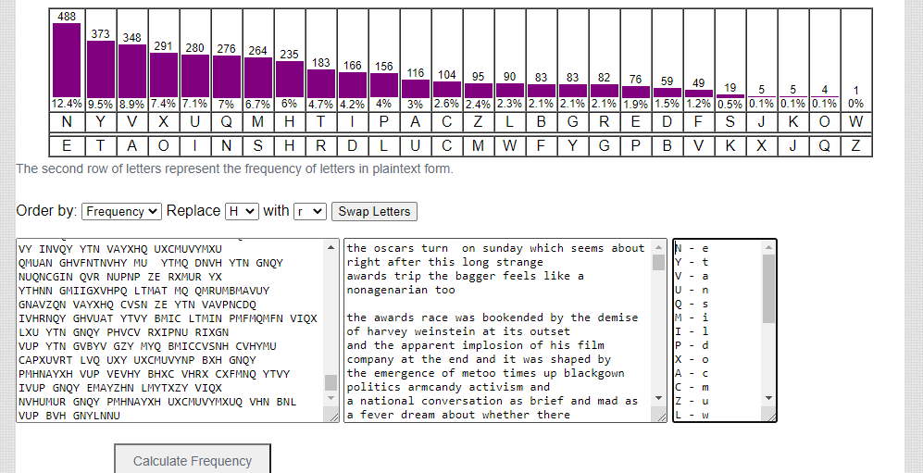

**Plain text:**

“the oscars turn on sunday which seems about right after this long strange awards trip the bagger feels like a nonagenarian too

the awards race was bookended by the demise of harvey weinstein at its outset and the apparent implosion of his film company at the end and it was shaped by the emergence of metoo times up blackgown politics armcandy activism and a national conversation as brief and mad as a fever dream about whether there ought to be a president winfrey the season didnt just seem extra long it was extra long because the oscars were moved to the first weekend in march to avoid conflicting with the closing ceremony of the winter olympics thanks pyeongchang

one big question surrounding this years academy awards is how or if the ceremony will address metoo especially after the golden globes which became a jubilant comingout party for times up the movement spearheaded by powerful hollywood women who helped raise millions of dollars to fight sexual harassment around the country

signaling their support golden globes attendees swathed themselves in black sported lapel pins and sounded off about sexist power imbalances from the red carpet and the stage on the air e was called out about pay inequity after its former anchor catt sadler quit once she learned that she was making far less than a male cohost and during the ceremony natalie portman took a blunt and satisfying dig at the allmale roster of nominated directors how could that be topped

as it turns out at least in terms of the oscars it probably wont be

women involved in times up said that although the globes signified the initiatives launch they never intended it to be just an awards season campaign or one that became associated only with red carpet actions instead a spokeswoman said the group is working behind closed doors and has since amassed million for its legal defense fund which after the globes was flooded with thousands of donations of or less from people in some countries

no call to wear black gowns went out in advance of the oscars though the movement will almost certainly be referenced before and during the ceremony especially since vocal metoo supporters like ashley judd laura dern and nicole kidman are scheduled presenters

another feature of this season no one really knows who is going to win best picture arguably this happens a lot of the time inarguably the nailbiter narrative only serves the awards hype machine but often the people forecasting the race socalled oscarologists can make only educated guesses

the way the academy tabulates the big winner doesnt help in every other category the nominee with the most votes wins but in the best picture category voters are asked to list their top movies in preferential order if a movie gets more than percent of the firstplace votes it wins when no movie manages that the one with the fewest firstplace votes is eliminated and its votes are redistributed to the movies that garnered the eliminated ballots secondplace votes and this continues until a winner emerges

it is all terribly confusing but apparently the consensus favorite comes out ahead in the end this means that endofseason awards chatter invariably involves tortured speculation about which film would most likely be voters second or third favorite and then equally tortured conclusions about which film might prevail

in it was a tossup between boyhood and the eventual winner birdman in with lots of experts betting on the revenant or the big short the prize went to spotlight last year nearly all the forecasters declared la la land the presumptive winner and for two and a half minutes they were correct before an envelope snafu was revealed and the rightful winner moonlight was crowned

this year awards watchers are unequally divided between three billboards outside ebbing missouri the favorite and the shape of water which is the baggers prediction with a few forecasting a hail mary win for get out

but all of those films have historical oscarvoting patterns against them the shape of water has nominations more than any other film and was also named the years best by the producers and directors guilds yet it was not nominated for a screen actors guild award for best ensemble and no film has won best picture without previously landing at least the actors nomination since braveheart in this year the best ensemble sag ended up going to three billboards which is significant because actors make up the academys largest branch that film while divisive also won the best drama golden globe and the bafta but its filmmaker martin mcdonagh was not nominated for best director and apart from argo movies that land best picture without also earning best director nominations are few and far between”

**Encryption Key:**

I manually calculated the key according to ‘order by frequency’ and this is the key I got:

N - e

Y - t

V - a

X - o

U - n

Q - s

M – i

H - r

T - h

I - l

P - d

A - c

C - m

Z - u

L - w

B - f

G - b

R – g

E - p

D - y

F - v

S - k

J - q

K - x

O - j

W - z

**Ques 2 – Encryption using different ciphers and modes:**

I applied encryption on a random text I saved in article.txt. The encryption command and their results are as follows:

**1. –aes-128-cbc**

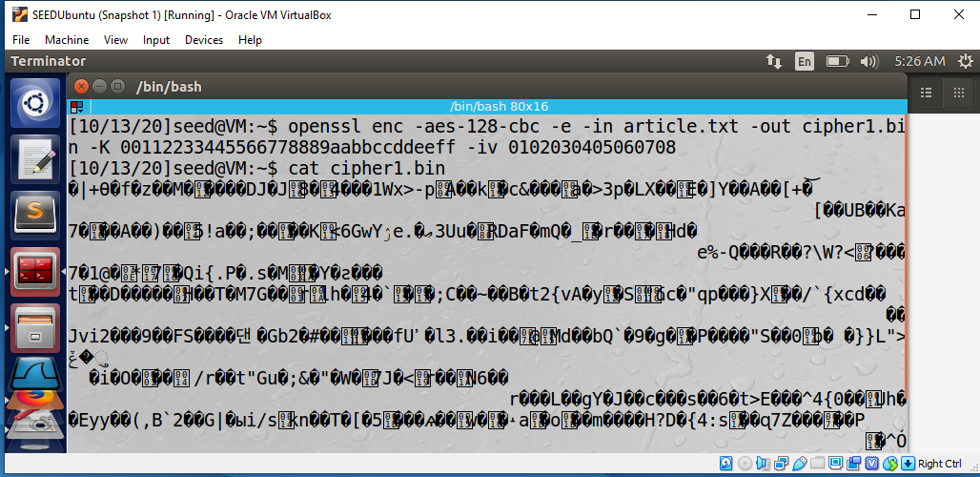

**2. –aes-128-cfb**

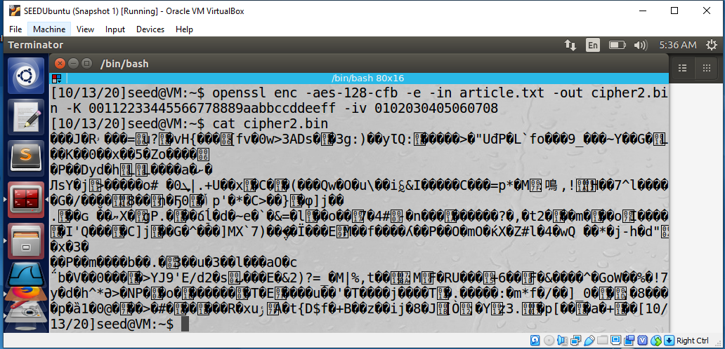

**3. –bf-cbc**

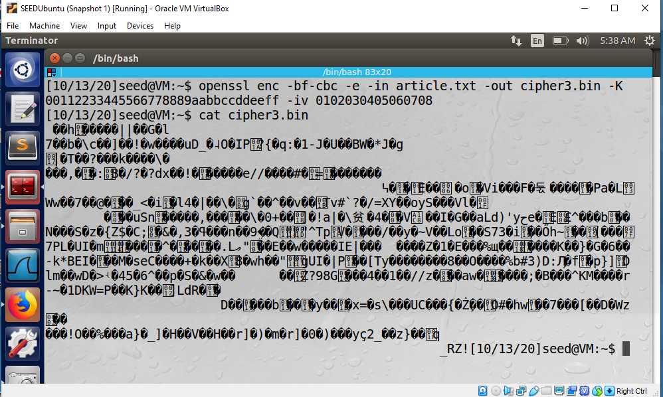

**Ques 3 - Encryption Mode – ECB vs. CBC:**

Performed cbc and ecb encryption on the picture.

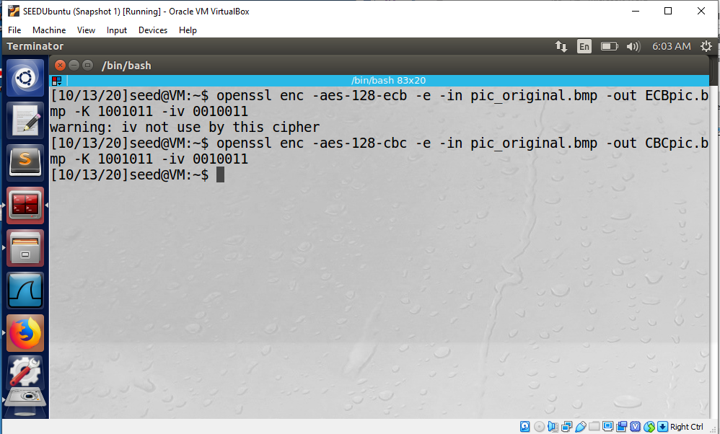

**1. ECB**

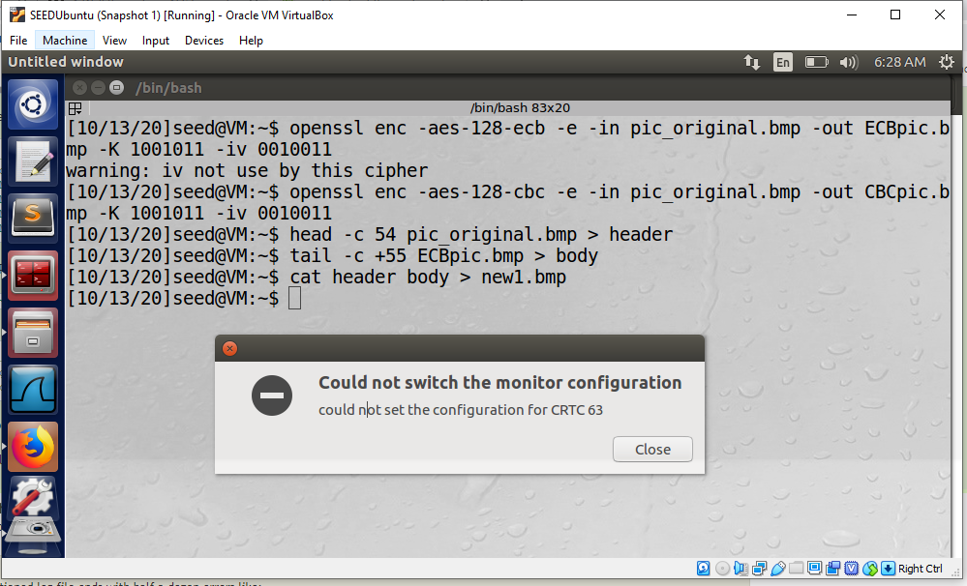

The output pic:

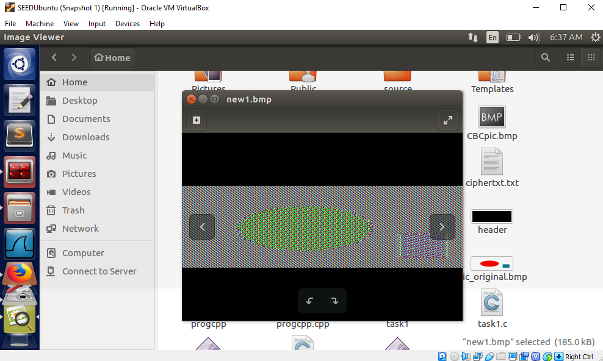

**2. CBC**

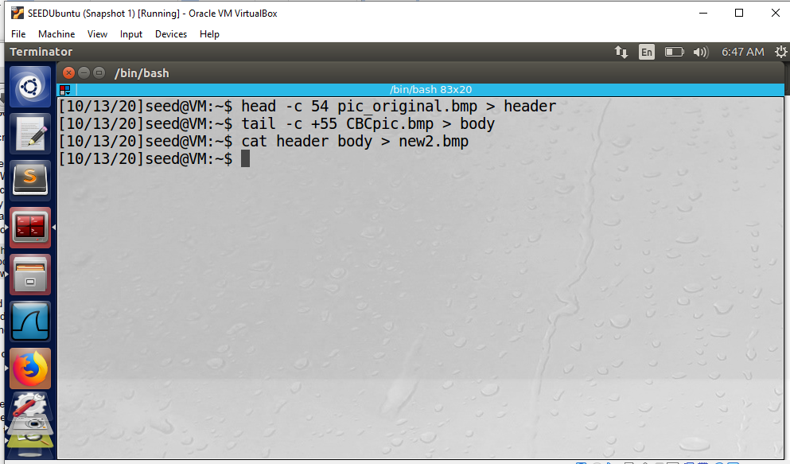

The output pic:

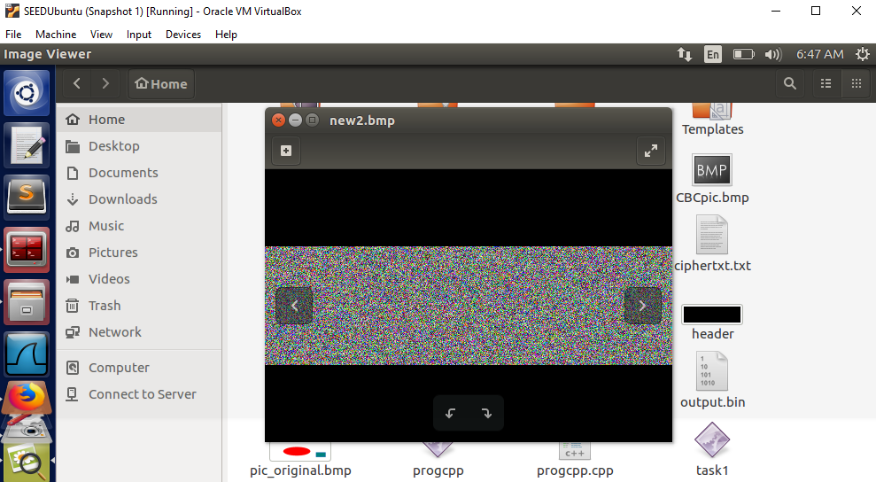

**Observation:**

When I encrypted the picture with ECB, I can still see the outline of the original pic and the picture is a bit recognizable. Therefore, ECB is not a good option for encrypting the pictures.

Whereas, when I encrypted the picture with CBC, it has been covered and encrypted perfectly that I am unable to detect original picture from it.

**Ques 4 – Padding:**

**Part 1:**

Made a file sample.txt and applied different modes of encryption on it.

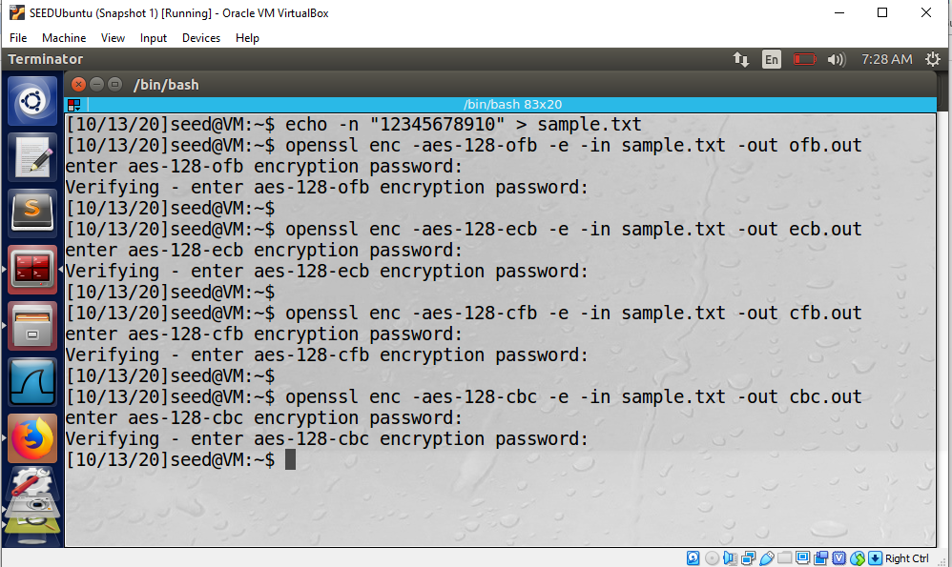

After encryption, the file size of files on which I did cbc and ebc, their sizes have increased therefore padding is done on it. And since they are block ciphers, they require padding. Whereas, ofb and cfb are stream ciphers and do not require padding.

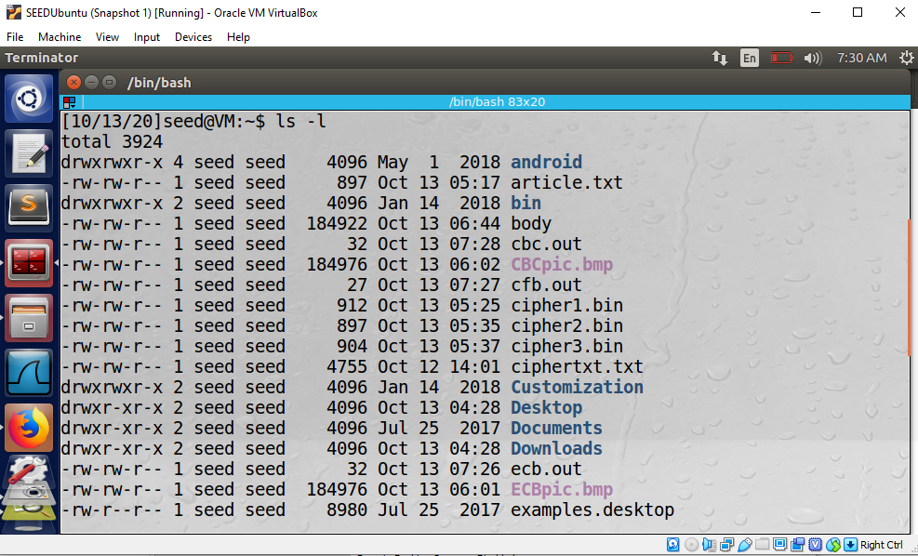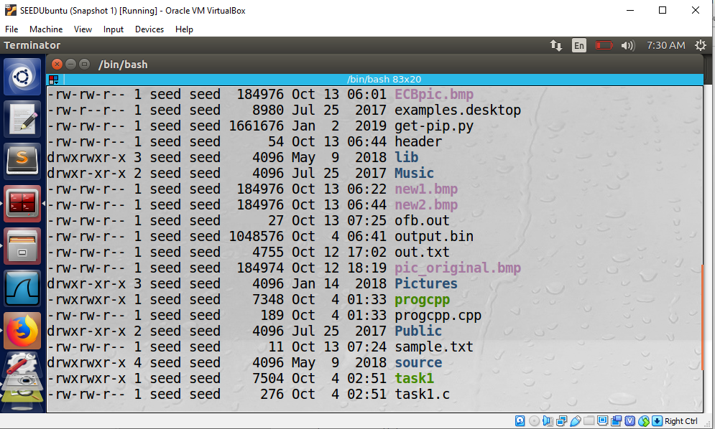

The following are the results of all 4 modes when I checked them with ‘hex bless’ to see the padding.

**- CBC**

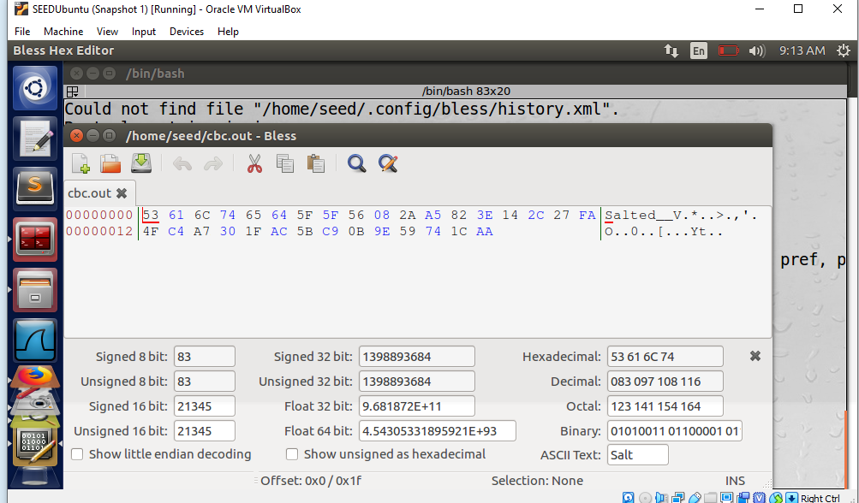

**-ECB**

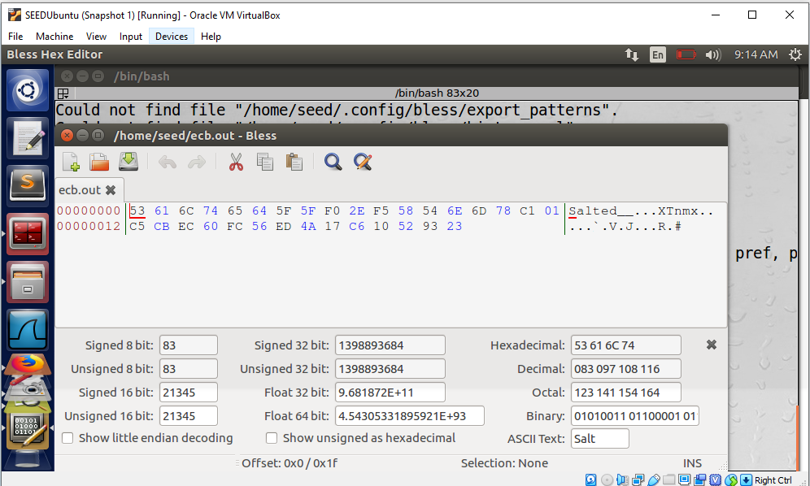

**-OFB**

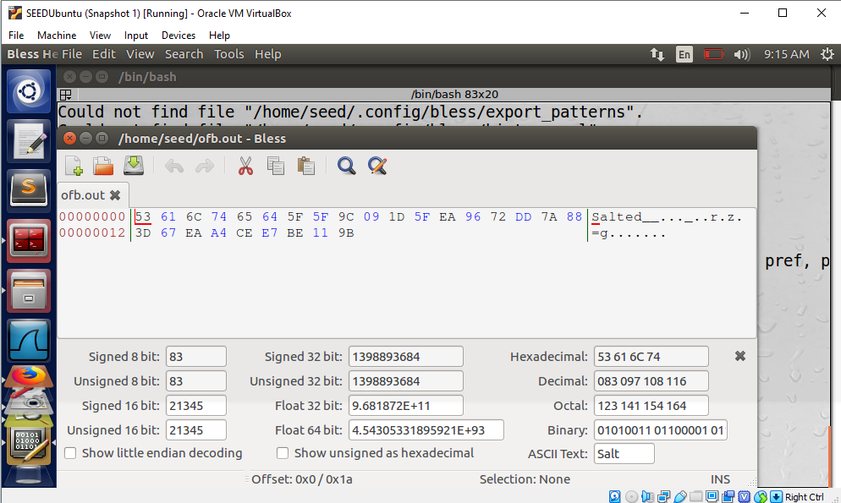

**-CFB**

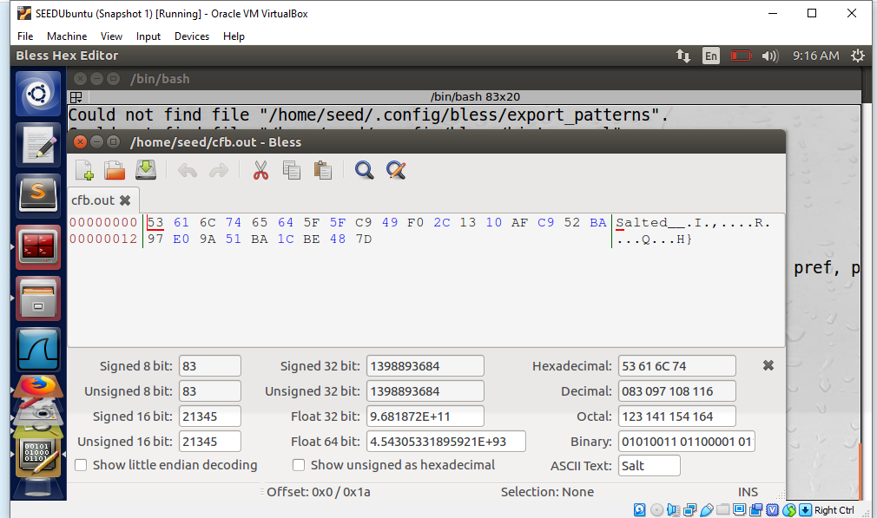

**Part 2:**

Created 3 files of 5, 10 and 16 bytes respectively and encrypted them with 128-bit AES with CBC mode. The sizes of the files before and after encryption can be seen in the screenshots below.

**Sizes before encryption:**

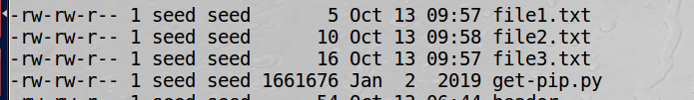

**While encrypting**

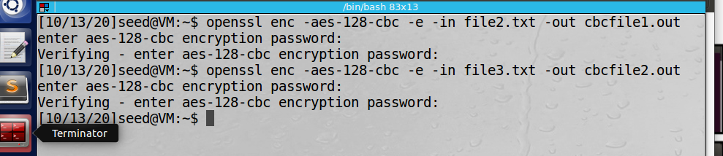

**After encryption**

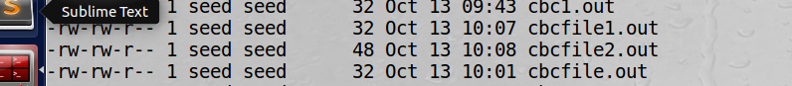

**Observation:**

The size of each file has increased after encryption is done on them

**Ques 5:**

1. Created a new file of 1000 bytes

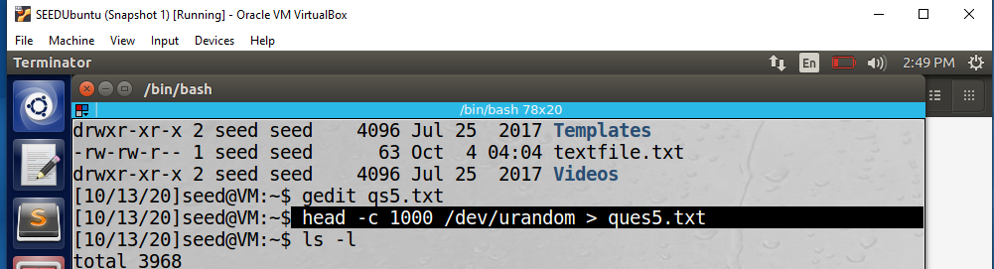

Can see the bytes of it:

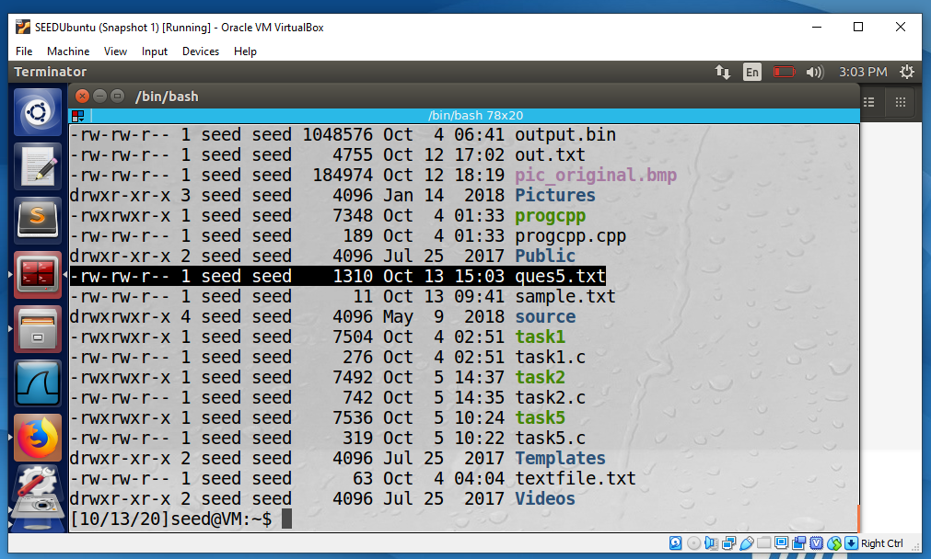

Added random text in it

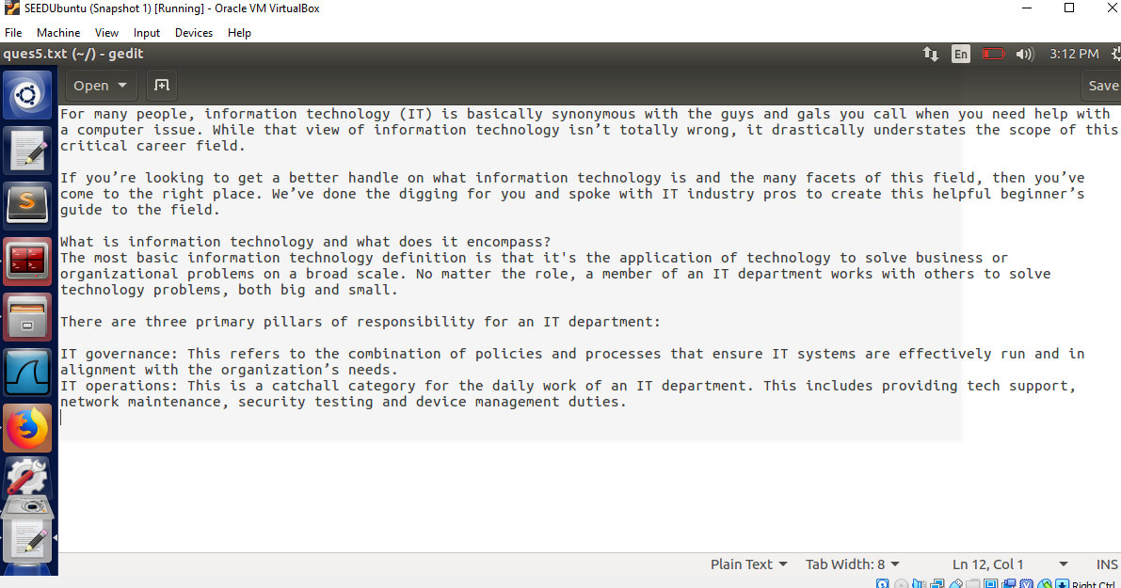

**CBC Encryption**

Did CBC encryption of input file.

This is the uncorrupted 55th byte in bless hex of our encrypted file.

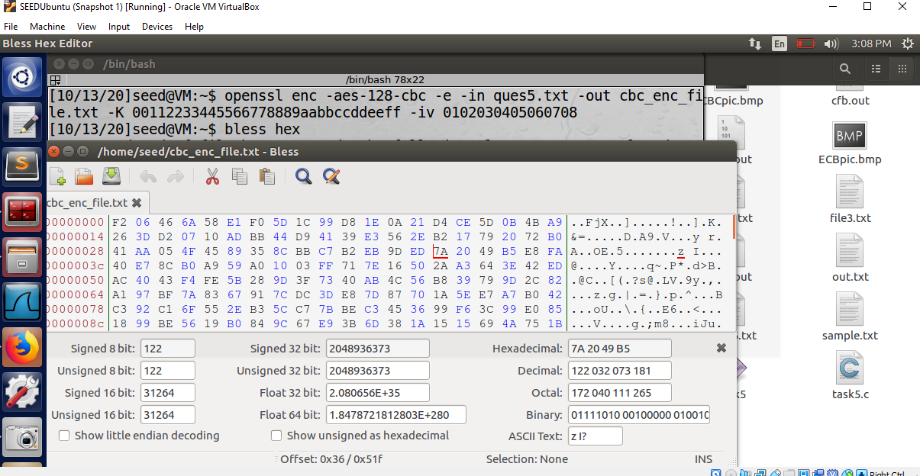

This is the corrupted bit:

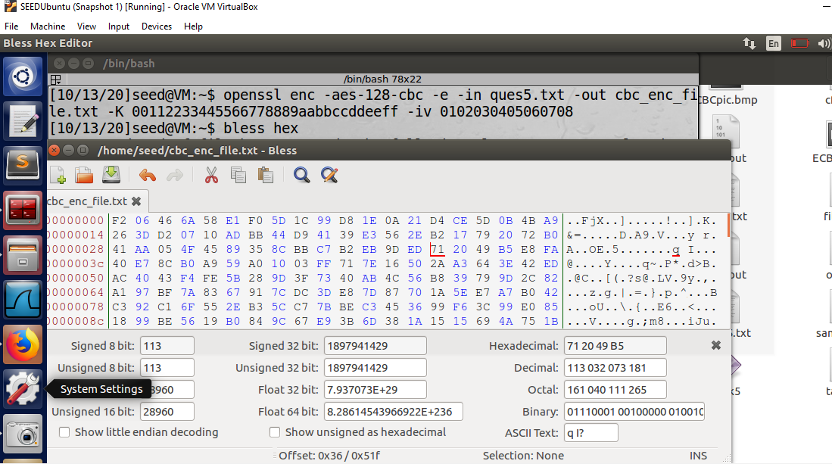

Did decryption of the file:

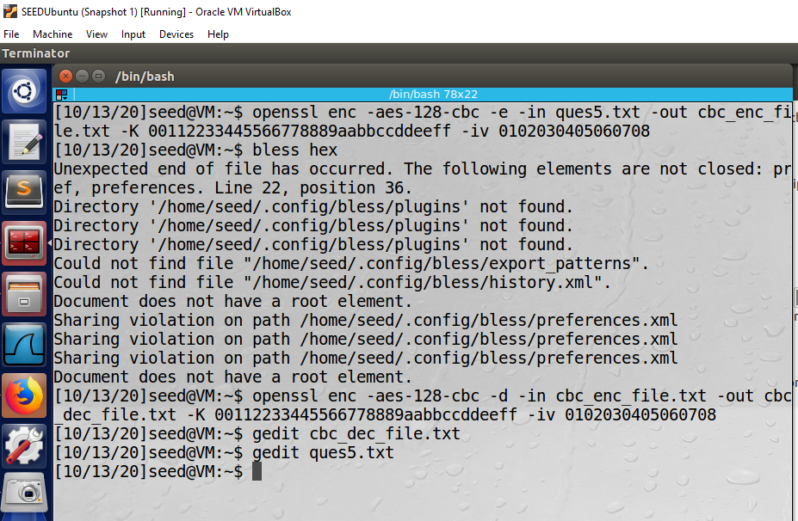

This is the decrypted text:

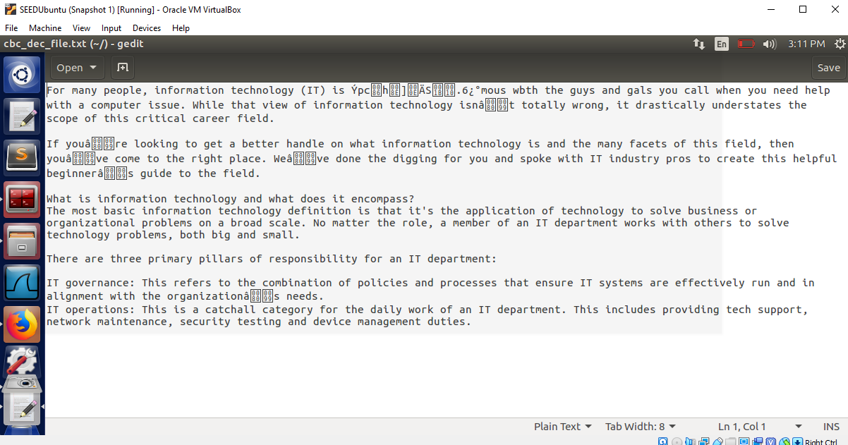

**Observation:**

In CBC mode, blocks of data has been lost at few different places and the error has propogated making certain bits affected by it too.

**ECB Encryption**

Did ECB encryption of input file.

This is the uncorrupted 55th byte in bless hex of our encrypted file.

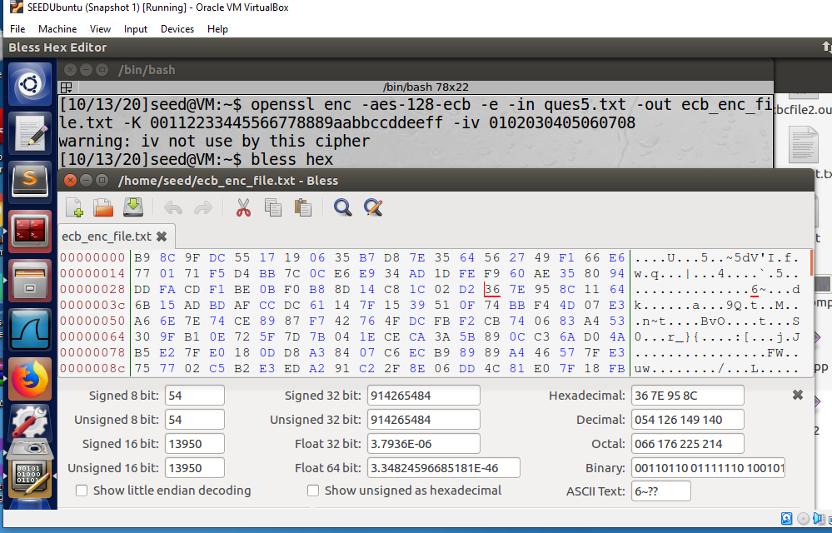

This is the corrupted bit:

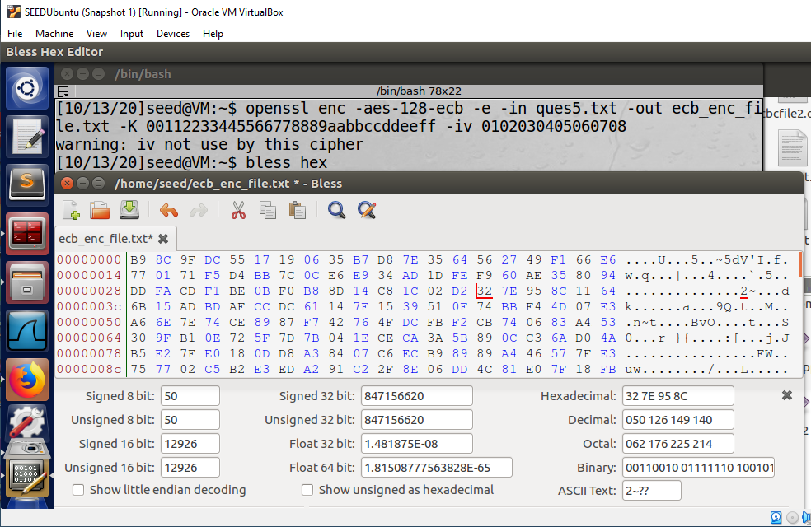

The decryption:

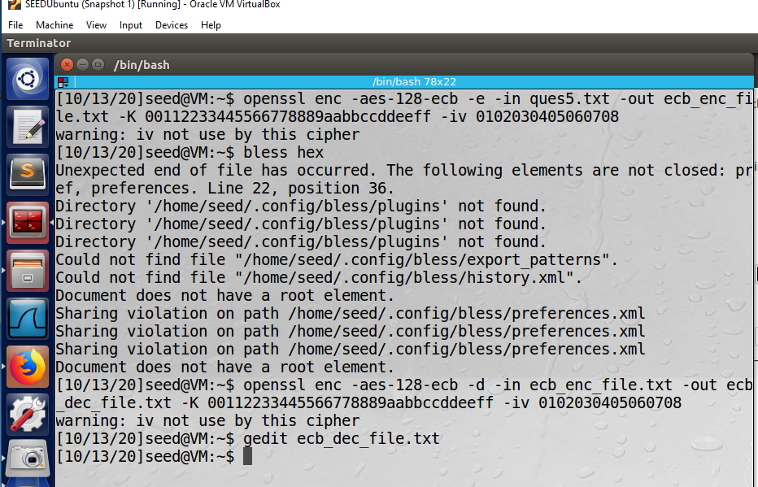

This is the decrypted text:

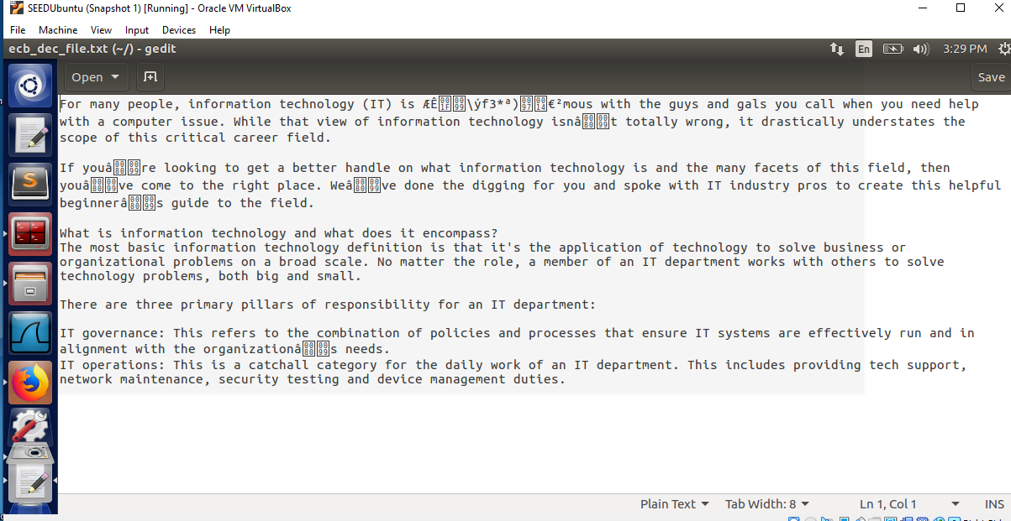

**Observation:**

In ECB mode, data is affected in blocks only. Where there is a problem in cipher it is in independent blocks.

**CFB Encryption**

Did CFB encryption of input file.

This is the uncorrupted 55th byte in bless hex of our encrypted file.

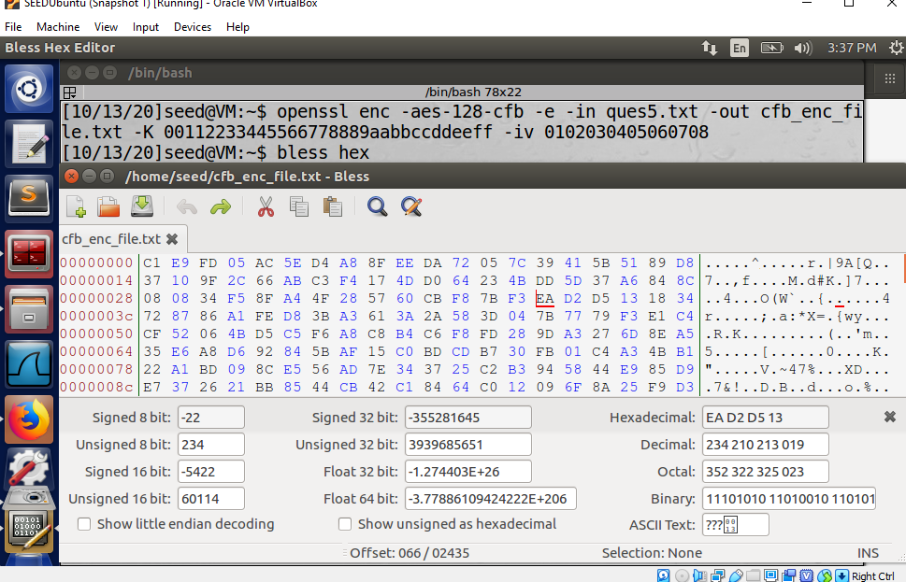

This is the corrupted bit:

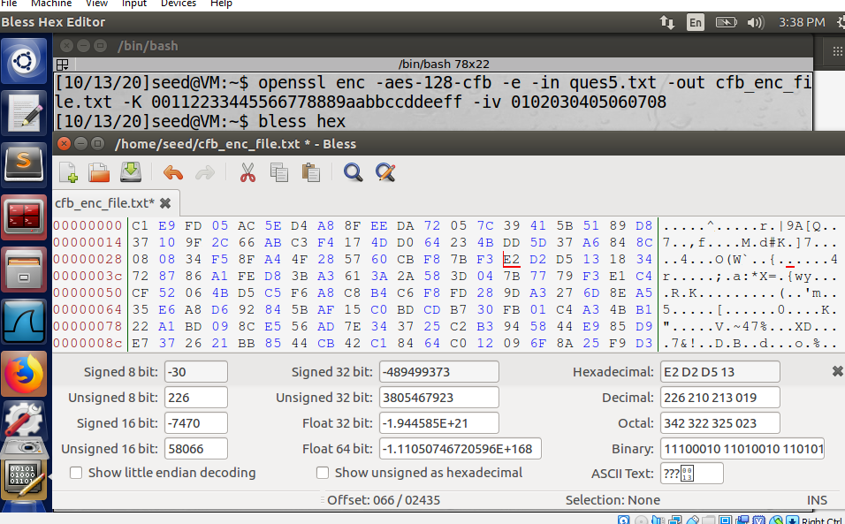

The decryption:

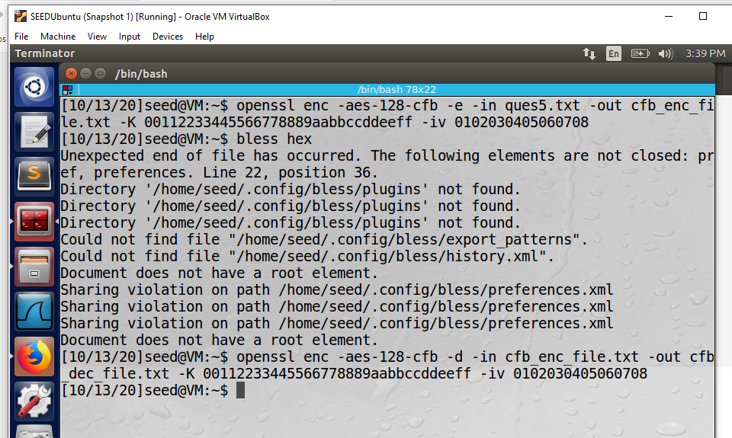

This is the decrypted text:

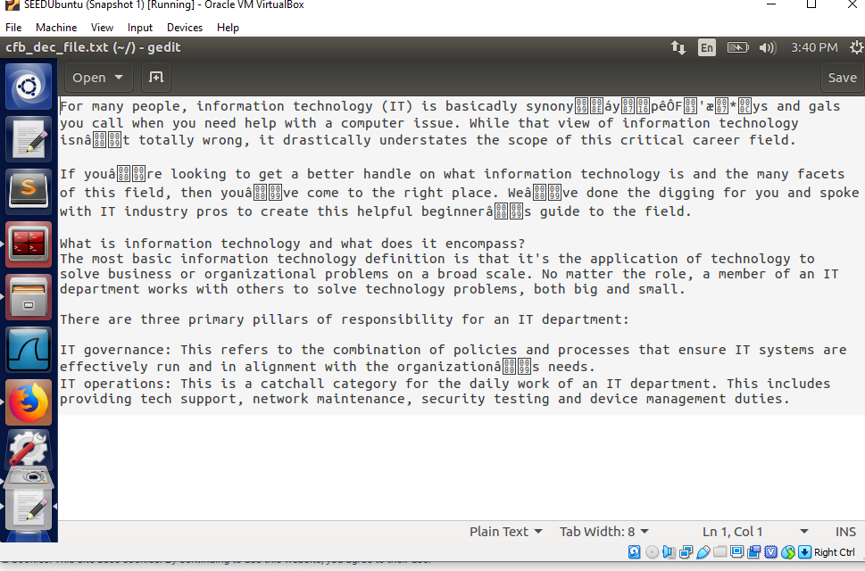

**Observation:**

In CFB mode, lesser number of random blocks have been affected by it making the error propagation factor poor in this mode.

**OFB Encryption**

Did OFB encryption of input file.

This is the uncorrupted 55th byte in bless hex of our encrypted file.

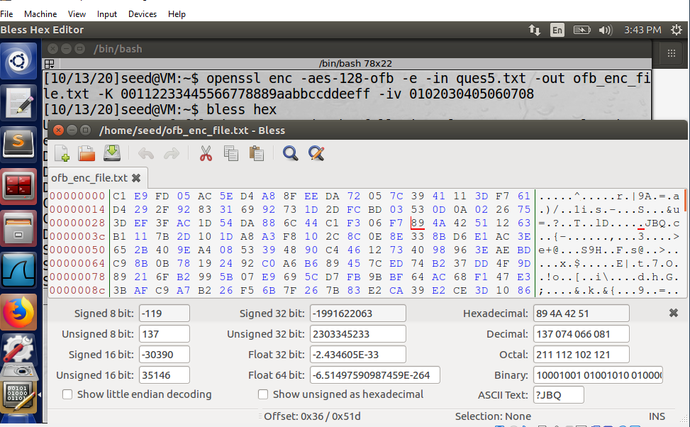

This is the corrupted bit:

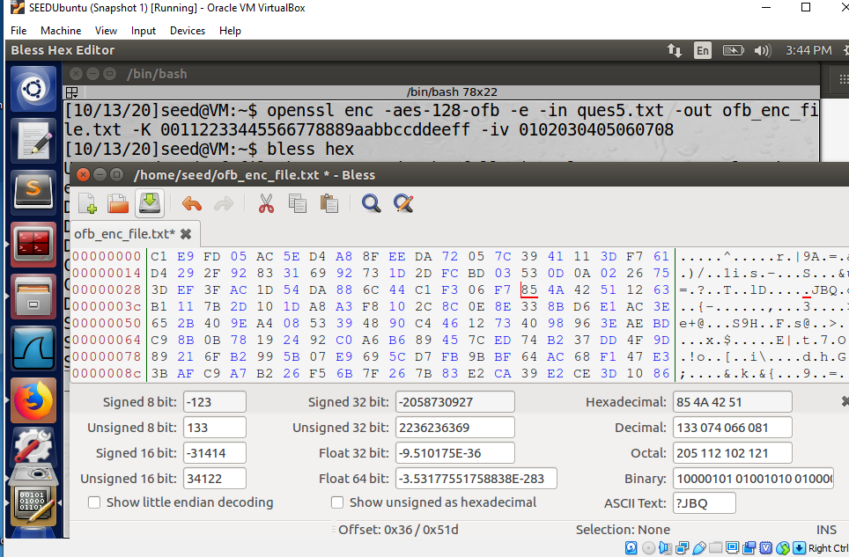

The decryption:

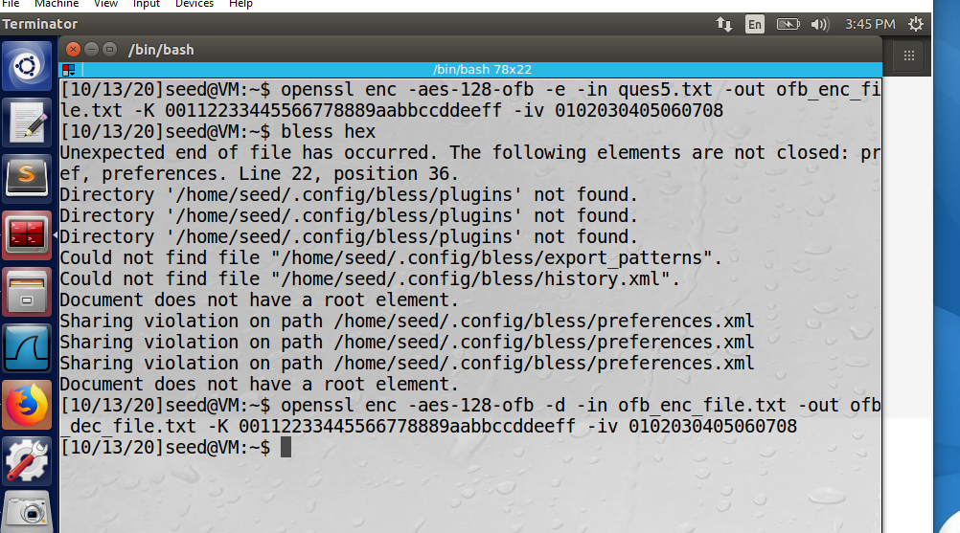

This is the decrypted text:

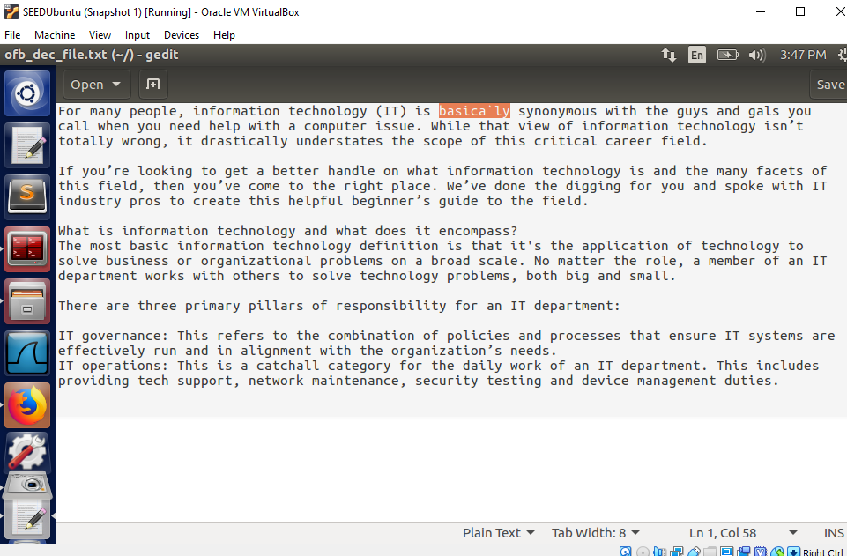

**Observation:**

In OFB mode, since it is not a block cipher, so when I corrupted the byte, the entire block didn’t get lost. Only that particular bit got garbage value when it was decrypted and the rest of the text in file remained safe.

**Therefore, out of all the modes, only OFB mode shows the most reliable and closest result to the original file.**

**Ques 6:**

**Task 6.1**

Made a text file and added random text in it

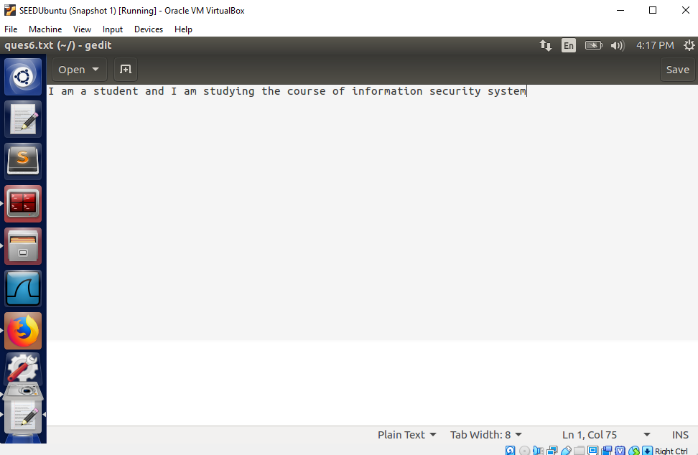

Encrypting with a vector 0000000012345678 for first time:

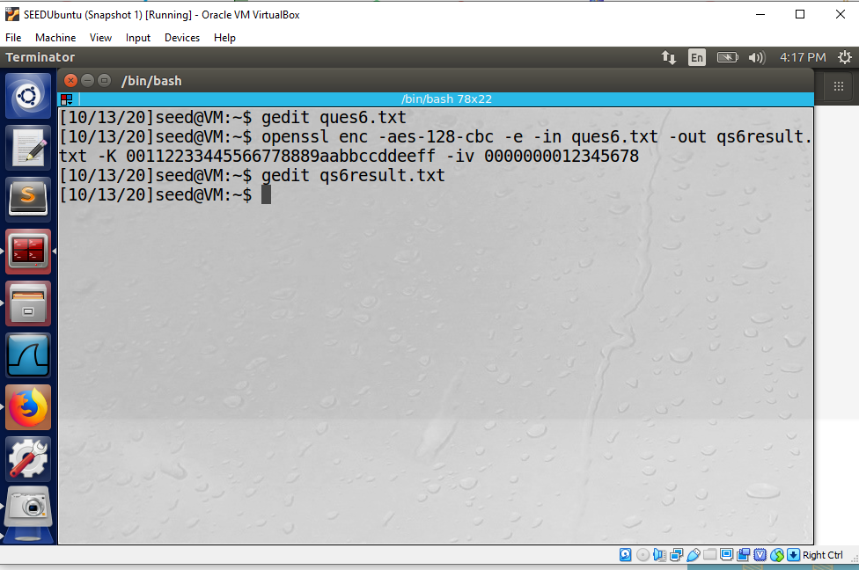

Result of encrypting with above given vector for first time:

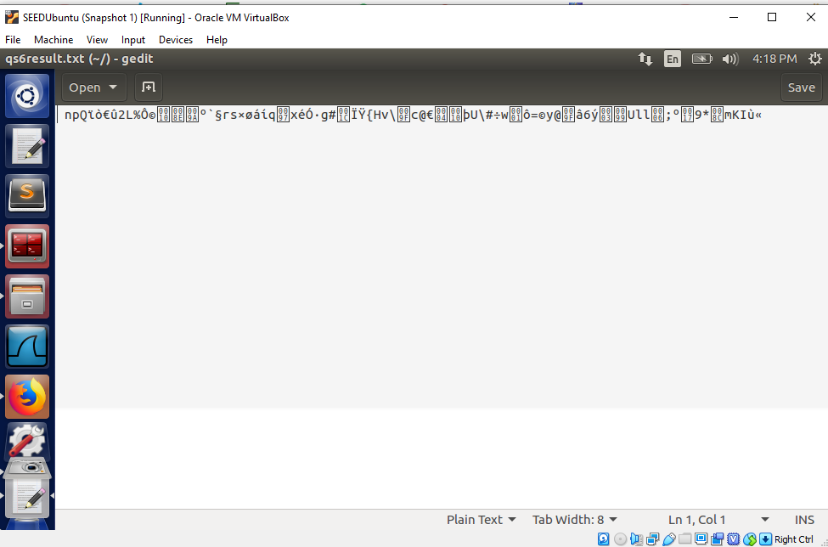

Encrypting with same vector 0000000012345678 for second time

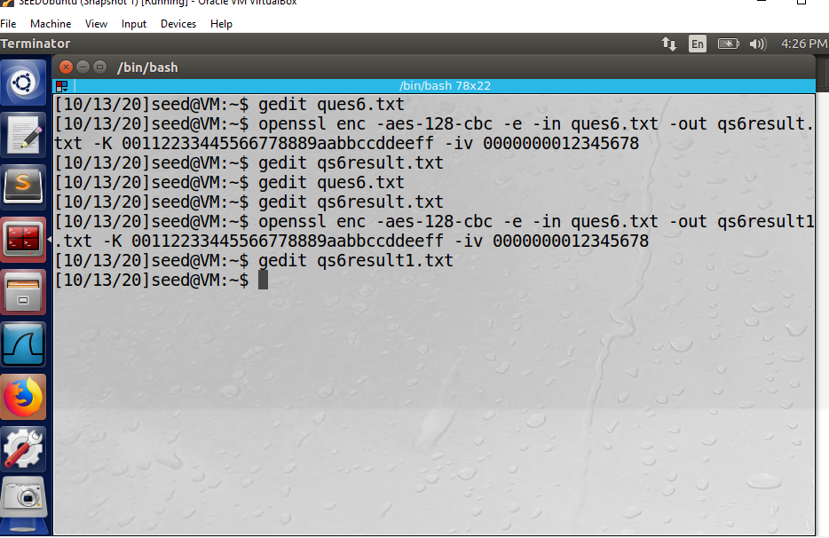

Result of second time encryption with same vector

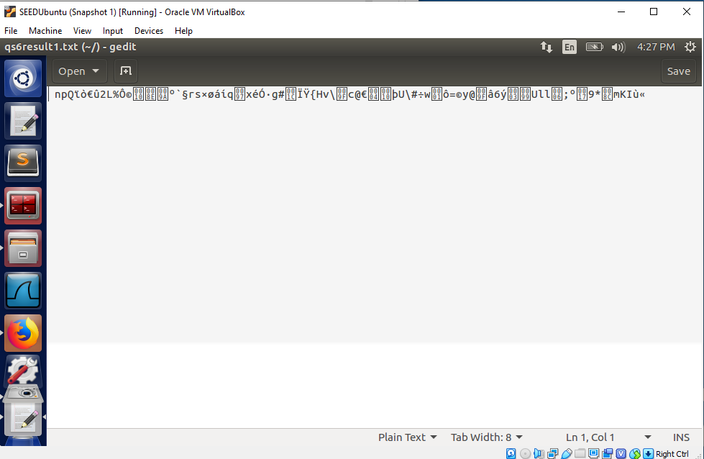

Encrypting same file with different vector 0000000011111111

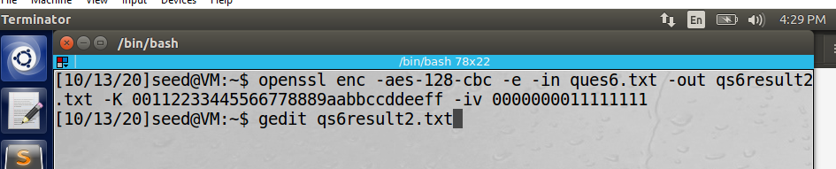

The result of encryption by different vector

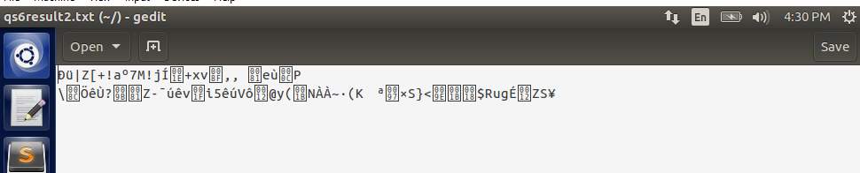

**Observation:**

When we encrypted same message 2 times with same vector, the result came out same. Whereas, when we changed the vector, the result came out different. Therefore, it is necessary to change the vector to make our file undetectable for the attacker.

**Task 6.2**

I applied xor on C1 and C2 and got this key 100110 through the online calculator.

If we replace OFB in this experiment with CFB, P2 will be revealed in blocks.